Section I: Scenario Demographics

Scenario Title: | Pregnant Cardiomyopathy
Date of Development: | (16/04/2018)
Target Learning Group: | Juniors (PGY 1 – 2) Seniors (PGY ≥ 3) All Groups

Section II: Scenario Developers

Scenario Developer(s): | Nadia Primiani and Sev Perelman
Affiliations/Institution(s): | Mount Sinai Hospital
Contact E-mail (optional):

Section III: Curriculum Integration

Learning Goals & Objectives
Educational Goal: | To manage acute CHF and cardiogenic shock in a pregnant patient with cardiomyopathy
CRM Objectives: | - Effectively lead a team through the uncommon presentation of cardiogenic shock in pregnancy  - Efficiently utilize closed-loop communication between team members  - Communicate with consultants early in the management of a sick pregnant patient
Medical Objectives: | - Recognize a critically ill pregnant patient with cardiogenic shock  - Work through the differential diagnosis of dyspnea in pregnancy  - Facilitate safe intubation with considerations for a pregnant patient

Case Summary: Brief Summary of Case Progression and Major Events
A 38-year-old female G2P1 at 36 weeks GA presents with acute on chronic respiratory distress in addition to chronic peripheral edema. She undergoes respiratory fatigue and hypoxia requiring intubation. She then becomes hypotensive which the team discovers is secondary to cardiogenic shock, requiring vasopressor infusion and consultation with Cardiology/ ICU.

References
Marx, J. A., Hockberger, R. S., Walls, R. M., & Adams, J. (2013). Rosen's emergency medicine: Concepts and clinical practice. St. Louis: Mosby.
Chris Nickson. (2013). Peripartum Cardiomyopathy. Accessed April 27, 2018 from https://lifeinthefastlane.com/ccc/peripartum-cardiomyopathy/

Section IV: Scenario Script

A. Clinical Vignette: To Read Aloud at Beginning of Case
You are working in a community ED and your team has been called urgently by the nurse to see a 38 year old female who is G2P1 at 36 weeks gestational age. She was brought in by her sister, who is quite agitated and upset, saying “everybody has been ignoring her symptoms for the last 4 weeks”. The patient has just experienced a syncopal episode at home.
B. Scenario Cast & Realism
Patient: | Computerized Mannequin |  |  |  |  | Realism:  Select most important dimension(s) |  |  | Conceptual
 | Mannequin |  |  |  |  |  |  |  | Physical
 | Standardized Patient |  |  |  |  |  |  |  | Emotional/Experiential
 | Hybrid |  |  |  |  |  |  |  | Other:
 | Task Trainer |  |  |  |  |  |  |  | N/A
Confederates | Brief Description of Role
Nurse | To assist at bedside, cue team to patient’s status PRN
RT | To assist with intubation
C. Required Monitors
EKG Leads/Wires |  |  | Temperature Probe |  |  |  | Central Venous Line
NIBP Cuff |  |  | Defibrillator Pads |  |  |  | Capnography
Pulse Oximeter |  |  | Arterial Line |  |  |  | Other: Fetal Doppler
D. Required Equipment
Gloves |  |  | Nasal Prongs |  |  |  | Scalpel
Stethoscope |  |  | Venturi Mask |  |  |  | Tube Thoracostomy Kit
Defibrillator |  |  | Non-Rebreather Mask |  |  |  | Cricothyroidotomy Kit
IV Bags/Lines |  |  | Bag Valve Mask |  |  |  | Thoracotomy Kit
IV Push Medications |  |  | Laryngoscope |  |  |  | Central Line Kit
PO Tabs |  |  | Video Assisted Laryngoscope |  |  |  | Arterial Line Kit
Blood Products |  |  | ET Tubes |  |  |  | Other:
Intraosseous Set-up |  |  | LMA |  |  |  | Other:
E. Moulage
Pregnant belly
F. Approximate Timing
Set-Up: |  | 5 min |  | Scenario: | 20 min |  |  | Debriefing: |  | 20 min

Section V: Patient Data and Baseline State

A. Patient Profile and History
Patient Name: Sunny Mills |  |  |  |  |  | Age: 38 |  |  |  |  |  |  |  | Weight: 75 kg
Gender: M F |  |  |  |  |  | Code Status: Full
Chief Complaint: Syncopal episode, now difficulty breathing
History of Presenting Illness: Aching legs with edema x 4 weeks. Mildly dyspneic since start of third trimester, dyspnea much worse today. Syncopal episode at home.
Past Medical History: |  | Single gestation pregnancy confirmed on 3rd trimester U/S |  |  |  |  | Medications: |  |  |  |  | Prenatal vitamins
Allergies: None
Social History: No drugs, no EtOH, lives with husband and child. No psychiatric history.
Family History: Non-contributory
Review of Systems: |  | CNS: |  |  | Nil
 |  | HEENT: |  |  | Nil
 |  | CVS: |  |  | Peripheral edema, bilateral legs > arms.
 |  | RESP: |  |  | Dyspnea worsening over 3rd trimester.
 |  | GI: |  |  | Nil
 |  | GU: |  |  | Pregnancy unremarkable. No vaginal bleeding or abdominal pain.
 |  | MSK: |  |  | Nil |  |  |  |  |  |  |  | INT: |  | Nil
B. Baseline Simulator State and Physical Exam
No Monitor Display |  |  |  | Monitor On, no data displayed |  |  |  |  |  |  | Monitor on Standard Display
HR: 110/min |  |  | BP: 90/50 |  |  |  |  | RR: 35 /min |  |  |  |  |  |  | O₂SAT: 89% on RA
Rhythm: Sinus rhythm |  |  | T:36.5 ºC |  |  |  |  | Glucose: 5.8 mmol/L |  |  |  |  |  |  | GCS: 15 (E4 V5 M6)
General Status: Moderate respiratory distress
CNS: | Alert, oriented, PEARL 3mm, normal reflexes, no clonus
HEENT: | Nil
CVS: | Sinus rhythm with PVC’s, peripheral edema 2+ to bilateral legs
RESP: | Respiratory distress, 2-3 word sentences, crackles to bases
ABDO: | Normal
GU: | Fundus palpated at xyphoid, non-tender
MSK: | Nil |  |  |  |  |  |  |  | SKIN: | Nil

Section VI: Scenario Progression
Scenario States, Modifiers and Triggers
Patient State | Patient Status | Learner Actions, Modifiers & Triggers to Move to Next State
1. Baseline State  Rhythm: Sinus tachycardia  HR: 110/min  BP: 90/50  RR: 35/min  O₂SAT: 89% RA  T: 36.5ºC  FHR: 150 bpm | Moderate respiratory distress, crackles on exam | Learner Actions  - History & physical (ABC’s)  - IV x 2, O2, monitors  - Fetal heart monitor or check FHR with Doppler  - Left lateral tilt with wedge  - Glucose check  - Labs – including trop, LFTs, and coags  - CXR  - ECG  - POCUS (FAST & OB normal Cardiac shows poor EF, Lung shows B lines)  - Call RT for BiPap  - Call OB for urgent C/S  - Trial 250-500ml IV NS bolus | Modifiers  Changes to patient condition based on learner action  - No O2 placed: SpO2 to 85%  - No lateral tilt: BP to 75/40  Triggers  For progression to next state  - All actions complete or 5 mins into case 2. Respiratory failure
2. Respiratory failure  Rhythm: Sinus tachycardia with PVC’s  HR: 115/min  BP: 95/50  RR: 40/min,  O₂SAT: 87% despite 100% FiO2  T: 36.5ºC | Worsening respiratory distress, drowsy. +++crackles and wheeze bilaterally  SpO2 starts dropping despite prior management | Learner Actions  - Call RT  - Call Anesthesia/ OB/ Cardiology/ NICU STAT  - BVM with PEEP or NIPPV prior to intubation  - Airway assessment (presume difficult airway)  - RSI medications  - Vasopressor at bedside (norepi, epinephrine, push dose phenylephrine)  - Intubation + PEEP  - Verbalize vent settings  - Post-intubation sedation | Modifiers  - If hypoxia is not noticed, RN to cue “I think she is becoming more drowsy and the sats are dropping. Should I call RT?”  - PPV prior to intubation SpO2 up to 95%  Triggers  - Intubation 3. Hypotension

3. Hypotension  Rhythm: sinus bradycardia  HR: 100/min  BP: 75/35  O2 sat: 95% with PEEP 10 | Sedated  Intubated  Ventilated | Learner Actions  - Consultants called (if not yet done)  - Start vasopressor (Norepinephrine ideal)  - Inotropes discussed +/- given (dobutamine 2.5-20 mcg/kg/min)  - ± Set up for arterial line | Modifiers  - Norepi started: BP to 80/40  - If no inotropes started, RN to cue: “What do you think is going on here? Is this all her heart?”  Triggers  - Inotropes started  4. Improvement
4. Improvement  Rhythm: sinus rhythm  HR: 80/ min  BP: 100/70  RR: 20  O2 sat: 95% on CMV | Sedated  Intubated  Ventilated | Learner Actions  - Initiates inotropes and furosemide based on Cardiology’s recommendations if not yet done  - STAT formal Echo  - Arterial line, central line (if not done)  - Call OB again | Modifiers  Triggers  - Cardiology staff arrives after 3 mins END CASE
Section VI: Scenario Progression

Section VII: Supporting Documents, Laboratory Results, & Multimedia

Laboratory Results
Na: 140 | K: 3.8 |  |  | Cl: 109 |  | HCO₃: 25 |  | BUN: |  | Cr: 65 |  |  | Glu: 5.8
Ca: 2.5 |  |  | Mg: 1.0 |  |  |  | PO₄: 0.90 |  |  |  | Albumin: 35
VBG |  | pH: 7.20 |  |  | PCO₂: 32 |  | PO₂: 98 |  | HCO₃: 23 |  |  | Lactate: 2.8
WBC: 16 |  |  | Hg: 120 |  |  |  | Hct: 0.370 |  |  |  | Plt: 280
Trop: 60

Images (ECGs, CXRs, etc.)
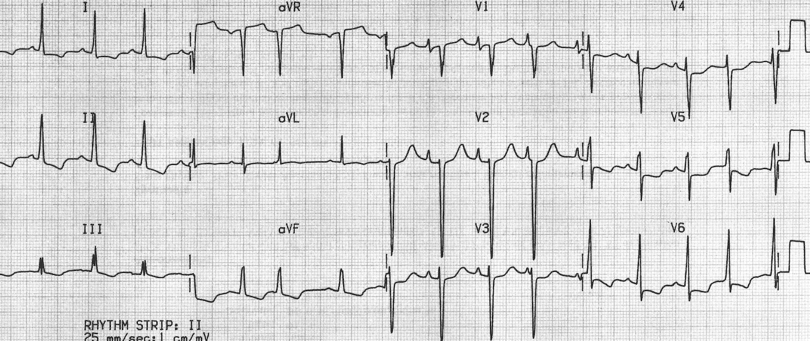  https://lifeinthefastlane.com/ecg-library/dilated-cardiomyopathy/ | 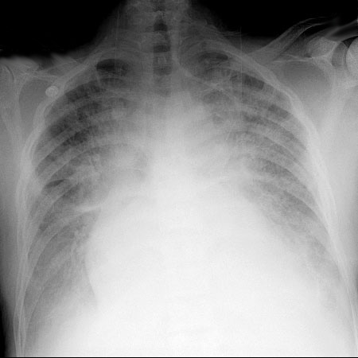  https://www.med-ed.virginia.edu/courses/rad/cxr/postquestions/posttest.html
POCUS (apical 4 chamber view)- Impaired EF  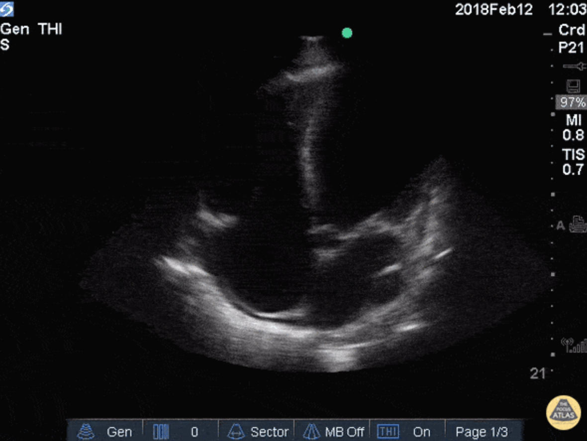  http://www.thepocusatlas.com/echo/2hj4yjl0bcpxxokzzzoyip9mnz1ck5 | POCUS Lung Views (Bilat)  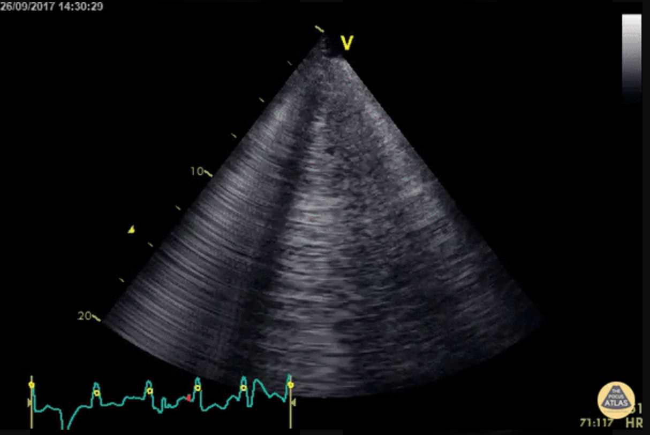  http://www.thepocusatlas.com/pulmonary/
FAST- RUQ (still)  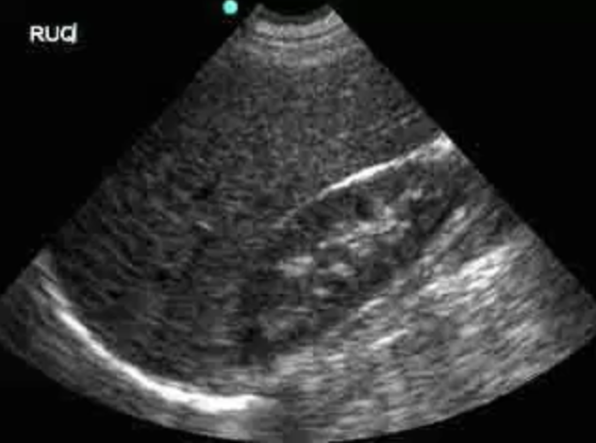  http://sinaiem.us/tutorials/fast/us-ruq-normal/ | FAST- OB with FHR  https://www.youtube.com/watch?v=SKKnTLqI_VM
Section VIII: Debriefing Guide

General Debriefing Plan
Individual | Group |  | With Video | Without Video
Objectives
Educational Goal: |  | To manage acute CHF and cardiogenic shock in a pregnant patient with cardiomyopathy
CRM Objectives: |  | - Effectively lead a team through the uncommon presentation of cardiogenic shock in pregnancy  - Efficiently utilize closed-loop communication between team members  - Communicate with consultants early in the management of a sick pregnant patient
Medical Objectives: |  | - Recognize a critically ill pregnant patient with cardiogenic shock  - Work through the differential diagnosis of dyspnea in pregnancy  - Facilitate safe intubation with considerations for a pregnant patient
Sample Questions for Debriefing
- What are the physiological and anatomical considerations in the resuscitation of a pregnant patient?
- Describe your differential for dyspnea in pregnancy
- What is on the differential for etiologies of cardiogenic shock? How can you clinically differentiate between these on initial examination?
- What are some risk factors for peripartum cardiomyopathy?
- What considerations must be made in the airway management of a pregnant patient? What about RSI medications?
Key Moments
- Recognizing and managing shock in a pregnant patient
- Intubation planning for the pregnant patient
- Providing inotropic support in a patient with cardiogenic shock

